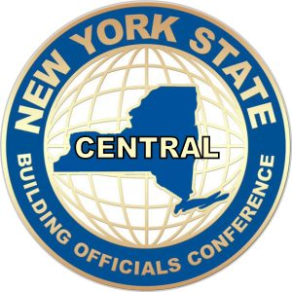 | NYSBOC CENTRAL CHAPTER  17th ANNUAL EDUCATIONAL CONFERENCE  APRIL 11TH & 12TH 2023
Embassy Suites by Hilton Syracuse Destiny USA
311 Hiawatha Blvd. W, Syracuse, New York 13204

VENDOR / SPONSOR
RESERVATION FORM / INVOICE

BASIC VENDOR COST: $350.00 To include 6’ Table, handouts for attendees (provided by vendor).
All meals & breaks as per conference itinerary for up to 2 persons.
Note: Hotel reservations not included but conference rates included.

Additional advertising opportunities for Vendor/Sponsors:
- $ 200.00 Noted as Co-Sponsor for Meals with public acknowledgement and display.
- $ 200.00 Display on Chapter Website for 1 year.

Display Schedule: April 11th Setup no later than 8:00am until 5:00pm.
April 12th Display from 8:00 am – 5:00 pm

Display Name: _____________________________________________________________
Contact Person: _____________________________________________________________
Contact Address: _____________________________________________________________
Email Address: _____________________________________________________________
Contact Number: _____________________________________________________________

PLEASE INDICATE WHICH LEVEL VENDOR/SPONSORSHIP (check box)

- Basic Display Table ( $350.00) [ ]
- Meals Co-Sponsor ($ 200.00) [ ]
- Chapter Website Display ($200.00) [ ]

Total: please indicate $ ____________________________________________________________

Registration application and payment must be submitted by April 3rd 2023
And can be payable by PayPal or checks made out to NYSBOC Central Chapter and sent to Edward Cusato @ 700 Orwood Pl, Syracuse NY. 13208
Any additional questions or problems contact Ed Cusato via email ecusato@salina.ny.us or via phone 315-243-9568.

WE LOOK FORWARD TO SEEING EVERYONE FOR ANOTHER GREAT YEAR AND AS ALWAYS THANK YOU FOR YOUR CONTINUED SUPPORT.

